-
VALUATION REPORT

OF

Mr. Kalpit Chokshi

At

Commercial Shop no. 4, Ground Floor, Futura, Near Seasons Mall, Mundhva – Kharadi Raod, Village - Hadapsar,
Tal. Haweli, CTS No. 4944/9A
Pune – 411028.

For

Bank Of India – Panchpakhadi, Thane Branch

BY

Manoj Kumar Sharma
Govt. Approved Valuer

To,
Bank Of India,
Panchpakhadi,
Thane Branch.

VALUATION REPORT

Ref No : UCVLLP/BOI/9338
Date: 10/12/2025
I | GENERAL
1 | Purpose for which the valuation is made
2 | a) | Date of Inspection |  | :
 | b) | Date on which the valuation is made |  | :
3 | List of photocopied documents produced for perusal
 | Agreement |  |  | :
 | Index-II |  |  | :
 | Other Documents |  |  | :
4 | Name of the owner(s) and his/ their address (es) with phone no. (details of share of each owner in case of joint ownership) |  |  | :
5 | Brief Description of the property |  |  | : | Address:  Landmark:  Building Details:  Property Details:  Amenities –  Landholding Type:
6 | Location of the property
 | a) |  | Plot No./ Survey No. | :
 | b) |  | Door No. | :
 | c) |  | T.S.No. / Village | :
 | d) |  | Ward / Taluka | :
 | e) |  | Mandal/ District | :
 | f) |  | Date of issue and validity of layout of approval map/plan | :
 | g) |  | Approval map/ Plan issuing authority | :
 | h) |  | Whether genuineness or  authenticity of approved map/plan is verified | :
 | i) |  | Any other comments by our  empanelment valuer on authentic of approved plan | :
7 | Postal address of the property |  |  | :
8 | City/ Town |  |  | :
 | Residential Area |  |  | :
 | Commercial Area |  |  | :
 | Industrial Area |  |  | :
9 | Classification of the Area
 | i) |  | High/ Middle/ Poor | :
 | ii) |  | Urban / Semi Urban/ Rural | :
10 | Coming under Corporation limit/ Village Panchayat Municipality |  |  | :
11 | Whether covered under any state/ Central Gory. Enactments (e.g., Urban Land Ceiling Act) or notified under agency area/ scheduled area/ cantonment area |  |  | :
12 | Boundaries of the Property |  |  |  | As per Deed | As per Actuals
13 | North |  |  | :
 | South |  |  | :
 | East |  |  | :
 | West |  |  | :
 | Dimensions of the site / Area of Shop |  |  | : | A |  | B
 |  |  |  |  | Area  (as per agreement) |  | Area as per Actual  (As per measurement)
14 | Extent of the site / area of Shop
14.1 | Latitude, Longitude & Co-ordinates of shop
15 | Extent of the site considered for valuation ( least of 13A & 13B)
16 | Whether occupied by owner/ tenant?  If occupied by tenant, since how long? Rent received per month

II | APARTMENT BUILDING
1. | Nature of the Apartment | :
2. | Location
 | T. S. No. | :
 | Shop No. | :
 | Village/Municipality/Corporation | :
 | Door No., Street or Road (Pin Code) | :
3. | Description of the locality Residential/ Commercial/ Mixed | :
4. | Year of Construction | :
5. | Number of Floors | :
6. | Type of Structure | :
7. | Number of dwelling units in the Building | :
8. | Quality of Construction | :
9. | Appearance of the Building | :
10. | Maintenance of the Building | :
11 | Facilities Available | :
 | Lift | :
 | Protect Water Supply | :
 | Underground Sewerage | :
 | Car Parking – Open/ Covered | :
 | Does Compound Wall exist? | :
 | Is pavement laid around the Building | :

III | Shop
1 | The Floor on Which Shop is situated | :
2. | Door No. of the Shop | :
3 | Specification of Shop
 | Roof | :
 | Flooring | :
 | Doors | :
 | Windows | :
 | Fitting | :
 | Finishing | :
4 | House Tax | :
 | Assessment No. | :
 | Tax paid in the name of | :
 | Tax amount | :
5 | Electricity Service Connection No. | :
 | Meter Card in the name of | :
6 | How is the maintenance of the Shop? | :
7 | Sale Deed executed in the name of | :
8 | What is the undivided area of land as per Sale Deed? | :
9 | What is the Plinth area/ Area of the Shop | : | Shop No. | Carpet Area | Built-up Area
10 | What is the floor space index (app.) | :
11 | What is the Carpet Area of the Shop | :
12 | Is it Posh/ I Class/ Medium / Ordinary | :
13 | Is it being used for residential or Commercial | :
14 | Is it Owner occupied or Let out? | :
15 | If rented, what is the monthly rent? | :

IV | MARKETABILITY
1 | How is the marketability? | :
2 | What are the factors favoring for an extra potential value | :
3 | Any negative factors are observed  Which affect the market value is general? | :

V | Rate
1 | After analyzing the comparable sale instances, what is the composite rate for a similar house with same specification in the adjoining locality? – (Along with details/ reference of at least two latest details/transaction with respect to adjacent properties in the area)
2 | Assuming is the new construction, what is the adopted basic composite rate of the shop under valuation after comparing with the specifications & other factor with the house under comparison (give Details) |  | :
3 | Break - up for the rate
 | i) | Building + Services | :
 | ii) | Land + Others | :
4 | Guideline rate obtained from the  Registrar’s office (an evidence thereof to be enclosed

VI | COMPOSITE RATE ADOPTED AFTER DEPRECIATION
a. | Depreciated Building Rate
 | Replacement cost of Shop with Services(v (3)i) | :
 | Age of the building | :
 | Life of the building estimated | :
 | Depreciation percentage assuming the salvage value as | :
 | Depreciated Ratio of the building | :
b. | Total composite rate arrived for valuation | :
 | Depreciated building rate VI (a) | :
 | Rate for Land & other V (3)ii | :
 | Total Composite Rate | :

Details of Valuation:

Sr.  No. | Description | Built up Area (sq.ft.) | Rate per sq.ft. (Rs.) | Estimated Value (Rs.)
1 | Present Value of the Shop | 1074 | 43,000/- | 4,61,82,000/-
2 | Car parking | 1 | 10,00,000/- | 10,00,000/-
3 | Government Charges and Stamp Duty | ---- | ---- | Nil
4 | Kitchen Arrangements | ---- | ---- | Nil
5 | Superfine Finish | ---- | ---- | Nil
6 | Interior Decorations | ---- | ---- | Nil
7 | Electricity deposits / electrical fittings, etc. | ---- | ---- | Nil
8 | Extra collapsible gates/grill works etc. | ---- | ---- | Nil
9 | Potential value, if any | ---- | ---- | Nil
10 | Others | ---- | ---- | Nil
 | Total |  |  | Rs.4,71,82,000/-
 | Say |  |  | Rs.4,72,00,000/-

Justification:

The value given in the report is the estimate of the Fair Market value of the property as on date, considering various aspects of the property like amenities in projects, locational advantages, demand and supply equation, etc. which is generally more than the Government ready reckoner value. Also the government rate remains same for many years and market rate changes as per the dynamics of market.

Valuation: Here, the approved valuer should discuss in details his approach to valuation of property and indicate how the value has been arrived at, supported by necessary calculation.
Also, such aspects as impending threat of acquisition by government for road widening/ public service purposes, sub merging & applicability of CRZ provisions (Distance from sea-coast / tidal level must be incorporated) and their effect on i) saleability ii) Likely rental value in future & iii) any likely income it may generated may be discussed : Approach : Land & Building and Market Approach

As a result of my appraisal & analysis, it is my considered opinion that the Fair Market Value of the above property in the prevailing condition with aforesaid specifications is Rs.4,72,00,000/- (In Words: Rupees Four Crore Seventy Two Lakh Only)

The Realizable value of Shop is Rs. 4,24,80,000/- (Rupees Four Crore Twenty Four Lakh Eightty Thousand Only).

The Distress Value of Shop is Rs.3,77,60,000/- (In Words- Rupees Three Crore Seventy Seven Lakh Sixty Thousand only).

Government Guideline value: Rs.1,08,04,440/- (In Words- Rupees One Crore Eight Lakh Four Thousand Four Hundred Forty Only)

The Insurance value of Shop is Rs. 26,85,000/- (In Words- Rupees Twenty Six Lakh Eighty Five Thousand Only)
The Rental Value of Shop is Rs.2,50,000/- per month (In Words- Rupees Two Lakhs Fifty Thousand Only)

Manoj Kumar Sharma

Manoj Kumar Sharma
B.E (Civil), F.I.V., M.I.E
Govt. Regd. Valuer
(IBBI/RV/07/2019/11044)

Date: 27/06/2025

The property was inspected by Myself (Manoj Kumar Sharma) on 08/12/2025 in Pune. We are satisfied with the Fair Market Value of the property is Rs.4,72,00,000/- (In Words: Rupees Four Crore Seventy Two Lakh Only)

Photographs

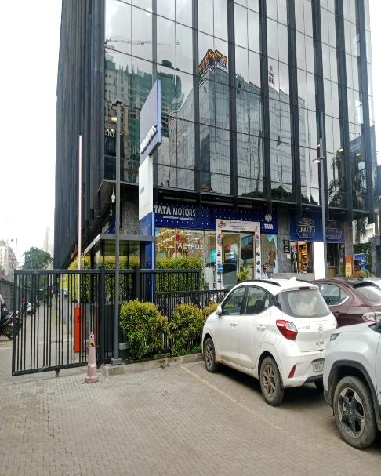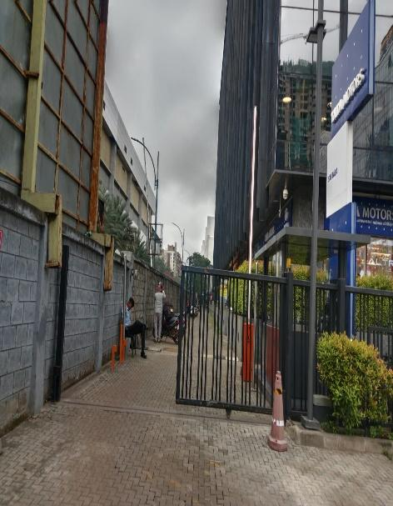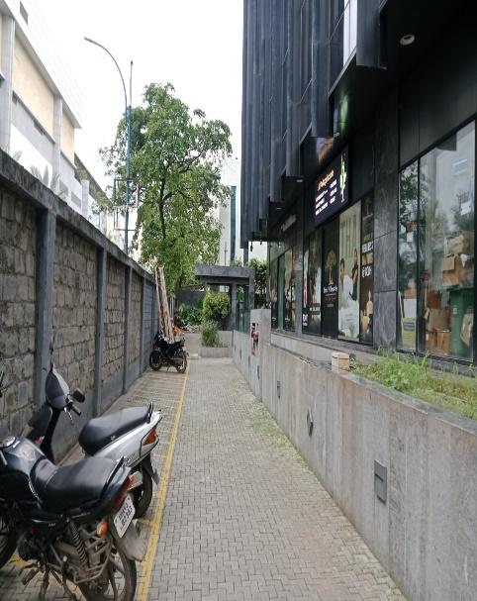

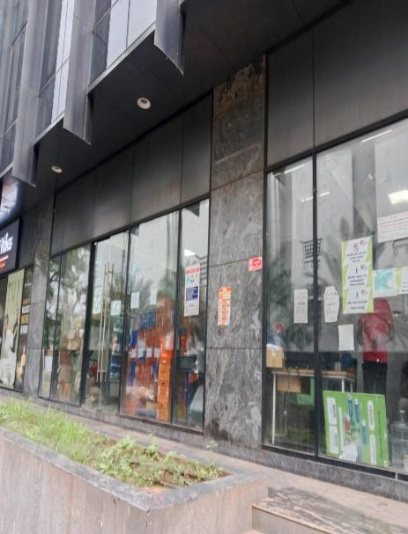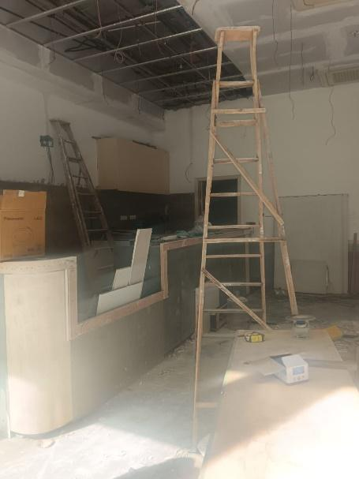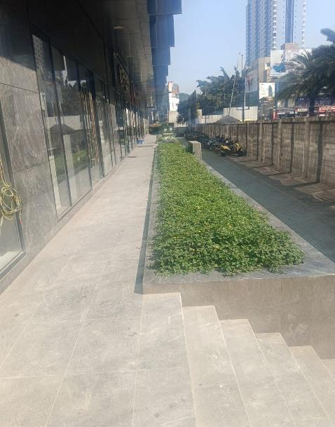

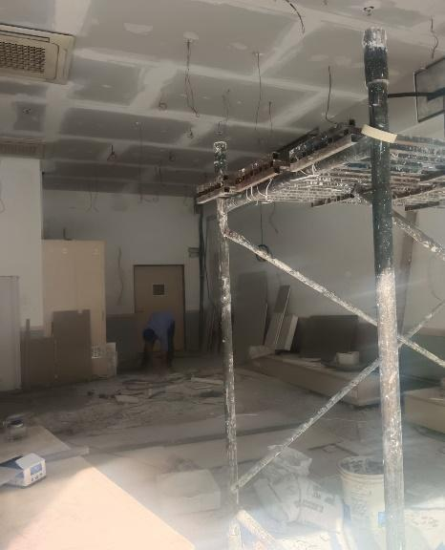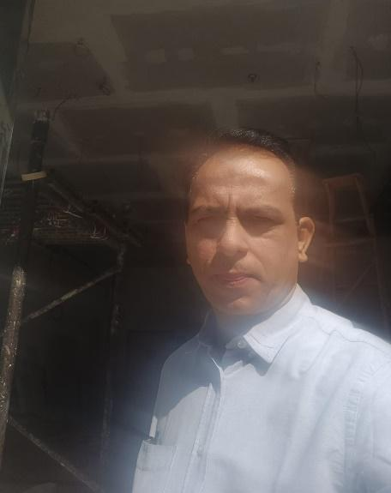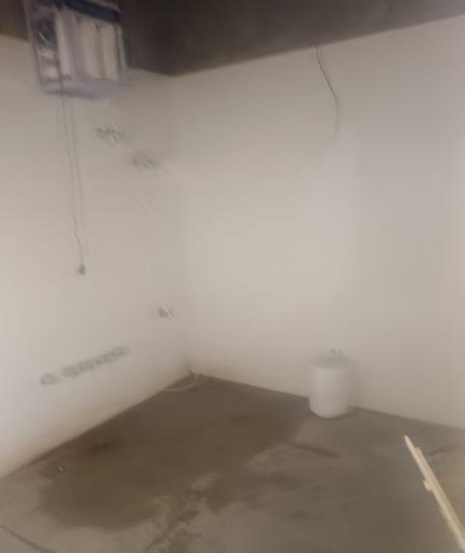

Google Map

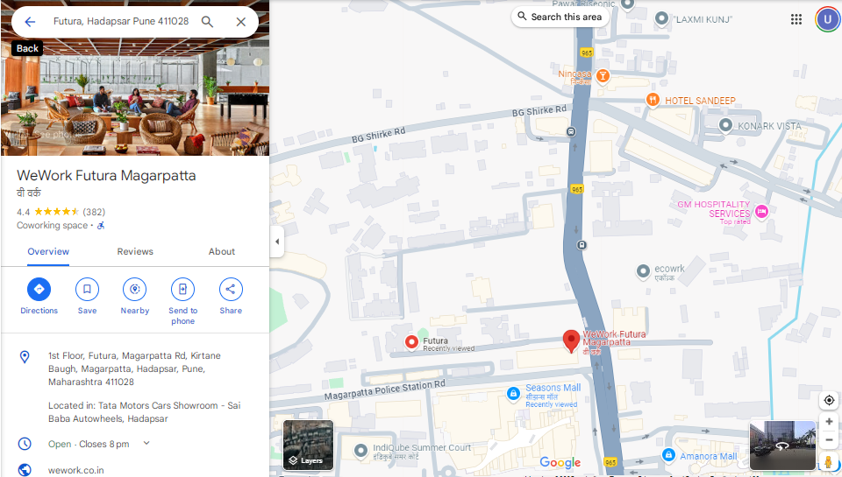
Stamp Duty Ready Reckoner for year 2025-2026
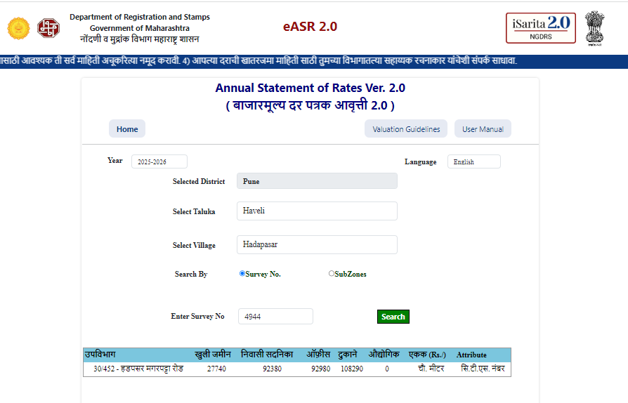
Property Listing
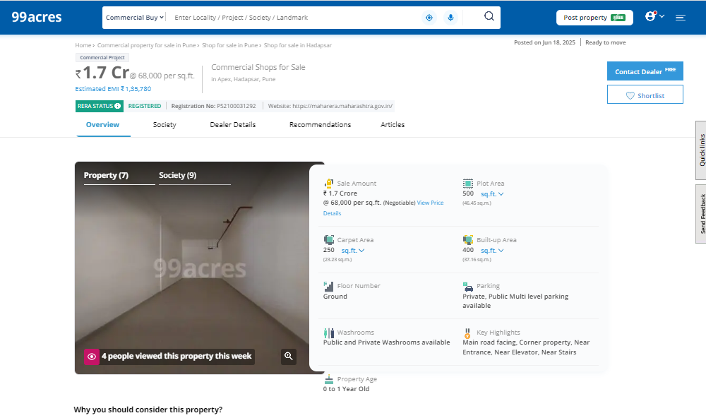

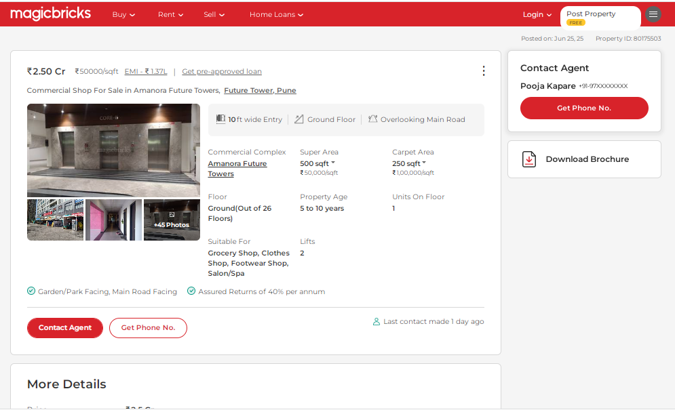

Disclaimer, Notes and Limitation:
- We have finalized the report on the basis of site visit and copy of: Sale agreement, Index-II and Agreement sale plan & O.C only. However, we have not been provided with C.C, approved plan, Title report etc. for verification purpose.
- The said property was tenant occupied and Final Interior work is going on at the time of inspection.
- This commercial shop used as a Coffee Shop
- In the observation the unit no. 3 & unit no. 4 are not internally merged.
- The property was inspected as shown by person met at site Mr. Kalpit Choshi - Owner.
- The said property is situated at Commercial area.
- The value given is considering all the amenities, surrounding area and locational advantage of the said property.
- We consider the area given in the agreement declared by the party and submitted for registration with the government authorities as final for valuation purpose. Any area that is not stated in the agreement is not considered for valuation unless the area is measured by us in which case that may be considered for valuation purpose.
- The scope of our valuation work is only for banks financial/loan purpose. Further, please be noted that this report shall not be used for any litigation purpose.
- Encumbrance of Loan, Government and other dues, stamp duty, registration charges, transfer charges etc., if any are not considered in the valuation. We assumed that the assets are free from encumbrance unless otherwise stated to us by the party in writing.
- The value given in our report is the estimate of the Fair Market value of the property as on date, considering various aspects of the property as mentioned above.

DECLARATION-CUM- UNDERTAKING

- I Mr. Manoj Kumar Sharma do hereby solemnly affirm and state that
  - I am a citizen of India.
  - I will not undertake valuation of any assets in which I have a direct or indirect interest or become so interested at any time during a period of three years prior to my appointment as valuer or three years after the valuation of assets was conducted by me.
  - The information furnished in my valuation report date 27/06/2025 is true and correct to the best of my knowledge and belief and I have made a04impartial and true valuation of the property.

Our representative Mr. Aditya Kawade has inspected the property on 26/06/2025.
  - Valuation report is submitted in the format as prescribed by the Bank.
  - I have not been depanelled/ delisted by any other bank and in case any such depanelment by other banks during my empanelment with you; I will inform you within 3 days of such depanelment.
  - I have not been removed/dismissed from service/employment earlier
  - I have not been convicted of any offence and sentenced to a term of imprisonment
  - I have not been found guilty of misconduct in professional capacity
  - I have not been declared to be unsound mind
  - I am not an undischarged bankrupt, or has not applied to be adjudicated as a bankrupt;
  - I am not an undischarged insolvent.
  - I have not been levied a penalty under section 271J of Income-tax Act, 1961 (43 of 1961) and time limit for filing appeal before Commissioner of Income tax (Appeals) or Income-tax Appellate Tribunal, as the case may be has expired, or such penalty has been confirmed by Income-tax Appellate Tribunal, and five years have not elapsed after levy of such penalty.

  - I have not been convicted of an offence connected with any proceeding under the Income Tax Act 1961, Wealth Tax Act 1957 or Gift Tax Act 1958and
  - I undertake to keep you informed of any events or happenings which would make me ineligible for empanelment as a valuer.
  - I have not concealed or suppressed any material information, facts and records and I have made a complete and full disclosure
  - I have read the Handbook on Policy, Standards and procedure for Real Estate Valuation, 2011 of the IBA and this report is in conformity to the “Standards” enshrined for valuation in the Part-B of the above handbook to the best of my ability. I have read the International Valuation Standards (IVS) and the report submitted to the Bank for the respective asset class is in conformity to the “Standards” as enshrined for valuation in the IVS in “General Standards” and “Asset Standards” as applicable.
  - I abide by the Model Code of Conduct for empanelment of valuer in the Bank. (Annexure V- A) signed copy of same to be taken and kept along with this declaration) t. I am registered under Section 34 AB of the Wealth Tax Act,1957.
  - My CIBIL Score and credit worthiness is as per Bank’s guidelines.
  - I am the proprietor authorized official of the firm, who is competent to sign this valuation report.
  - I will undertake the valuation work on receipt of Letter of Engagement generated from the system (i.e. LLMS/LOS) only.
  - Further, I hereby provide the following information.
  - If this format if found changed than it is done as per the requirement of the respective branches. If nothing is heard within 15 days from the date of this report then it is presumed that the valuation report is accepted by the bank in to. To accept or reject our valuation report is sole discretion of the Bank as well the quantum of loan amount disbursement to your customers on the basis of our valuation will be decided by the bank and we are not held responsible for any changes in the market rates in the future, including becoming NPAs of any properties due to any reason whatsoever.
  - Whilst we have taken the opportunity of looking through the documents (whatever available) it is recommended that the relevant documents are subjected to formal legal inspection in order to ensure that there are no elements, restriction or charge contained which are likely to have detrimental effect upon the valuation provided.

Sr.  No. | Particulars | Valuer comment
1 | background information of the asset being valued;
2 | purpose of valuation and appointing authority
3 | identity of the valuer and any other experts involved in the valuation;
4 | disclosure of valuer interest or conflict, if any;
5 | date of appointment, valuation date and date of report;
6 | inspections and/or investigations undertaken;
7 | nature and sources of the information used or relied upon;
8 | procedures adopted in carrying out the valuation and valuation standards followed;
9 | restrictions on use of the report, if any;
10 | major factors that were taken into account during the valuation;
11 | major factors that were not taken into account during valuation;
12 | Caveats, limitations and disclaimers to the extent they explain or elucidate the limitations faced by valuer, which shall not be for the purpose of limiting his responsibility for the valuation report.

